

**AlbertaSat**

**Ex-Alta 3 COTS ADCS Trade Study**

**Version 0.50**

**Jan 23, 2024**

University of Alberta

Institute for Space Science Exploration and Technology



# Document Authentication

|  |  |  |  |
| --- | --- | --- | --- |
| **Lead Author** | | | |
| **Name** | **Position** | **Signature** | **Date** |
| Ryan Bererton | ADCS Team Lead |  | Jan 22, 2024 |
| Spencer Leaf | ADCS Team Member |  | Jan 22, 2024 |
| Kailen Philip | ADCS Team Member |  | Jan 22, 2024 |
| Tom Cundict | ADCS Team Member |  | Jan 22, 2024 |

|  |  |  |  |
| --- | --- | --- | --- |
| **Reviewed by** | | | |
| **Name** | **Position** | **Signature** | **Date** |
| Joanne Cai | Ex-Alta 3 Deputy Project Manager |  | January 25, 2024 |
| Andre Ulliac | Alumni Advisor,  formerly Northern SPIRIT ADCS Lead |  | January 27, 2024 |
|  |  |  |  |

The undersigned acknowledge that they have reviewed this document, and they authorize the objectives, rules, and organization of the project as described in this document. Any changes to this document will be coordinated with and approved by the undersigned or their designated representatives

|  |  |  |  |
| --- | --- | --- | --- |
| **Approved by** | | | |
| **Name** | **Position** | **Signature** | **Date** |
|  |  |  |  |
|  |  |  |  |
|  |  |  |  |

# Record of Document Changes

|  |  |  |  |  |
| --- | --- | --- | --- | --- |
| **Version** | **Effective Date** | **Author(s)** | **Section(s) Changed** | **Description of Change(s)** |
| 0.10 | 10/29/23 | Ryan Bererton | N/A | Creation |
| 0.5 | 1/22/24 | Ryan Bererton  Tom Cundict  Kailen Philip  Spencer Leaf  Connor McNeill | All | Info added to all sections, document ready for review  Formatting |
|  |  |  |  |  |

# 

# Copyright Information

All work in this document is protected by the Apache License 2.0 open source license.

|  |
| --- |
| Copyright [2023] [Ryan Bererton, Kailen Philip, Tom Cundict, Spencer Leaf]  Licensed under the Apache License, Version 2.0 (the "License");  you may not use this file except in compliance with the License.  You may obtain a copy of the License at  http://www.apache.org/licenses/LICENSE-2.0  Unless required by applicable law or agreed to in writing, software  distributed under the License is distributed on an "AS IS" BASIS,  WITHOUT WARRANTIES OR CONDITIONS OF ANY KIND, either express or implied.  See the License for the specific language governing permissions and  limitations under the License. |

# 

# Executive Summary

This document is the trade study for the selection of the ADCS module for the Ex-Alta 3 mission and includes all the information used to make that decision. The companies and systems that were considered are:

* AAC Clyde Space’s iADCS200
* Tensor Tech’s ADCS 10-m
* CubeSpace’s Gen 1 and Gen 2 systems
* Serenum Space’s VAC02

Blue Canyon Technologies was originally considered but was dropped because the price was known to be prohibitively above budget.

Each system was compared using fourteen different aspects:

* Components
* Configurability
* Mass
* Dimensions
* Interfacing
* Power Draw
* Radiation Hardening
* AI&T Feasibility
* Pointing
* Documentation
* Technical Support
* Price
* Lead Time
* Lifetime

Each aspect for each system was given a value and multiplied by a weight, with all values determined by the ADCS team. Using these values and the information gathered about each system, a recommendation was given for the best system, which was the CubeADCS Gen 2. Each of the other systems either had one aspect that made it infeasible to purchase, or a combination of factors that made it a worse option than CubeSpace.

# 

# Acronyms and Abbreviations

|  |  |
| --- | --- |
| **ADCS** | Attitude Determination and Control System |
| **GSD** | Ground Sample Distance |
| **FOV**  **CSS**  **FSS** | Field of View  Coarse Sun Sensor  Fine Sun Sensor |
| **SSO EM**  **FFC**  **MCB**  **IMU**  **U**  **MOI**  **COTS**  **GNSS**  **MTQ**  **CMG**  **EHS**  **mNms**  **mNm**  **Am2**  **AI&T** | Sun Synchronous Orbit  Engineering Model  Flexible Flat Cable  Main Control Board  Inertial Measurement Unit  Unit  Moment of Inertia  Commercial off the Shelf  Global Navigation Satellite System  Magnetorquer  Control Moment Gyro  Earth Horizon Sensor  milli-Newton-meter-second  milli-Newton-meter  Amp-meter-squared  Assembly integration and testing |
| **ROM** | Rough Order of Magnitude |
|  |  |
|  |  |
|  |  |
|  |  |
|  |  |
|  |  |
|  |  |

# 

# Table of Contents

**Document Authentication 2**

**Record of Document Changes 3**

**Copyright Information 4**

**Executive Summary 5**

**Acronyms and Abbreviations 2**

**Table of Contents 3**

**1 ADCS Subsystem Overview 1**

1.1 System Requirements 1

1.2 Budget 3

1.3 Schedule 4

1.4 Volume Budget 4

1.5 Mass Budget 4

1.6 Power Budget 4

**2 AAC Clyde Space 4**

2.1 System Description 5

2.2 Components 5

2.3 Configurability 6

2.4 Mass 6

2.5 Dimensions 7

2.6 Interfacing 9

2.7 Power Draw 9

2.8 Radiation Hardening 9

2.9 AI&T Feasibility 9

2.10 Pointing 9

2.11 Documentation 10

2.12 Technical Support 10

2.13 Price 10

2.14 Lead Time 11

2.15 Lifetime 11

**3 Tensor Tech 11**

3.1 System Description 11

3.2 Components 11

3.3 Configurability 12

3.4 Mass 13

3.5 Dimensions 14

3.6 Interfacing 15

3.7 Power Draw 15

3.8 Radiation Hardening 15

3.9 AI&T Feasibility 16

3.10 Pointing 16

3.11 Documentation 16

3.12 Technical Support 17

3.13 Price 17

3.14 Lead Time 17

3.15 Lifetime 17

**4 CubeSpace Gen 1 17**

4.1 System Description 17

4.2 Components 18

4.3 Configurability 18

4.4 Mass 19

4.5 Dimensions 19

4.6 Interfacing 24

4.7 Power Draw 26

4.8 Radiation Hardening 27

4.9 AI&T Feasibility 27

4.10 Pointing 27

4.11 Documentation 28

4.12 Technical Support 28

4.13 Price 28

4.14 Lead Time 28

4.15 Lifetime 29

**5 CubeSpace Gen 2 29**

5.1 System Description 29

5.2 Components 30

5.3 Configurability 31

5.4 Mass 32

5.5 Dimensions 32

5.6 Interfacing 37

5.7 Power Draw 38

5.8 Radiation Hardening 40

5.9 AI&T Feasibility 40

5.10 Pointing 40

5.11 Documentation 41

5.12 Technical Support 41

5.13 Price 41

5.14 Lead Time 41

5.15 Lifetime 42

**6 Serenum Space 42**

6.1 System Description 42

6.2 Components 44

6.3 Configurability 44

6.4 Mass 45

6.5 Dimensions 45

6.6 Interfacing 45

6.7 Power Draw 46

6.8 Radiation Hardening 46

6.9 AI&T Feasibility 46

6.10 Pointing 46

6.11 Documentation 47

6.12 Technical Support 47

6.13 Price 47

6.14 Lead Time 47

6.15 Lifetime 47

**7 Comparison 47**

7.1 Criteria Description 47

7.1.1 Price (8) 47

7.1.2 Mass (5) 48

7.1.3 Dimensions (10) 48

7.1.4 Interfacing (6) 48

7.1.5 Pointing (10) 48

7.1.6 Configurability (4) 48

7.1.7 Technical Support (7) 48

7.1.8 Lead time (7) 49

7.1.9 AI&T Feasibility (9) 49

7.1.10 Power Draw (8) 49

7.1.11 Documentation (7) 49

7.1.12 Radiation Hardening (3) 49

7.1.13 Components (6) 50

7.1.14 Lifetime (4) 50

7.2 Comparison Table 50

**8 Recommendation 51**

**9 Reference Documents 53**

**Appendix 55**

# 

# ADCS Subsystem Overview

## System Requirements

In the table is listed relevant system requirements for the ADCS and will be updated as requirements change.

|  |  |  |  |  |  |
| --- | --- | --- | --- | --- | --- |
| **Requirement Number** | **Requirement Version** | **Definition Updated** | **Design Consideration** | **Design Specification/Requirement** | **Rationale** |
| **EX3-ADC-F-001** | 0.10 | July 16, 2023 | Detumble | Ex-Alta 3 shall detumble from the tumbling rates provided by the launch provider within 20 days. | NanoRacks specifies the expected tip-off rates from deployment in NR-NRCSD-S0004: Req. 4.1.6. Time period taken from NS requirements. |
| **EX3-ADC-P-003** | 0.10 | July 16, 2023 | Pointing Control Accuracy | Ex-Alta 3 shall achieve a pointing control accuracy of +/- 2.0 degrees in roll, pitch and yaw angles during imaging mode | Needed to keep features within the FOV of Iris. Calculated from the chosen sensor for Iris, calculations shown in this document:<https://docs.google.com/document/d/1yeTKvN0N3u-AxALonxoQShgMfVAHCwZYWCcKGUGhQ5E/edit> |
| **EX3-ADC-P-004** | 0.10 | July 16, 2023 | Pointing Control Accuracy | Ex-Alta 3 shall achieve a slew rate control of 0.07 deg/s during imaging mode | Needed to prevent image blur while Iris is imaging. Calculated from the chosen sensor for Iris, calculations shown in this document:<https://docs.google.com/document/d/1yeTKvN0N3u-AxALonxoQShgMfVAHCwZYWCcKGUGhQ5E/edit> |
| **EX3-ADC-P-005** | 0.10 | August 28, 2023 | Pointing Measurement Accuracy | Ex-Alta 3 shall achieve a pointing knowledge accuracy of +/- 0.45 degrees in roll, pitch, and yaw angles during imaging mode | Needed to locate Iris images with reasonable accuracy after they are captured. Calculated from the overall position error, calculations shown in this document:<https://docs.google.com/document/d/1yeTKvN0N3u-AxALonxoQShgMfVAHCwZYWCcKGUGhQ5E/edit> |
| **EX3-ADC-P-007** | 0.10 | July 16, 2023 | Spacecraft recovery | Ex-Alta 3 shall have the capability to recover from a spin of up to 50 deg/s within 10 days | SC needs to be able to recover from a high spin rate within a reasonable amount of time to return to nominal operations |
| **EX3-ADC-P-009** | 0.10 | December 1, 2023 | Pointing Control Accuracy | Ex-Alta 3 shall be able to achieve a pointing control accuracy of +/- 5 degrees in roll, pitch and yaw angles from the ground station and the Sun during payload downlink and Sun tracking modes, respectively. | Ex-Alta 3 needs to track the S-band ground station with enough accuracy to increase the link time with the ground station every available pass |
| **EX3-ADC-P-013** | 0.10 | February 14, 2024 | Pointing Measurement Accuracy | Ex-Alta 3 shall achieve a slew rate knowledge accuracy of 0.07 deg/s during imaging mode. | Need to be able to measure the rate at least as good as we need to control the slew rate, calculations shown in this document:<https://docs.google.com/document/d/1yeTKvN0N3u-AxALonxoQShgMfVAHCwZYWCcKGUGhQ5E/edit> |
| **EX3-ADC-P-014** | 0.10 | February 14, 2024 | Spacecraft Attitude | Ex-Alta 3 shall achieve a minimum slew rate of 0.87 deg/s during payload downlink mode. | Needed to track the S-band ground station as the satellite passes directly overhead, calculations shown in this document:<https://docs.google.com/document/d/1yeTKvN0N3u-AxALonxoQShgMfVAHCwZYWCcKGUGhQ5E/edit> |

## Budget

|  |  |  |  |
| --- | --- | --- | --- |
| ADCS | Nominal (CAD) | Best Case (CAD) | Worst Case (CAD) |
| ADCS Unit | $50,160.00 | $40,128.00 | $60,192.00 |
| Simulation Software | $5,000.00 | $4,000.00 | $6,000.00 |
| Total | $55,160.00 | $44,128.00 | $66,192.00 |

## Schedule

We want the hardware in our possession by September 2024 which gives 22 weeks from the end of March. September 2024 is the beginning of AI&T for EX3 and there is only 12 months allocated to this phase of the mission, which is significantly shorter than AI&T for EX2. Having as much time as possible to complete AI&T is crucial to the success of the mission, so it is very important to get hardware by September 2024.

## Volume Budget

As of PDR, the volume budget allocates to the ADCS 62.5 mm in the stack, 63.1 mm with contingency.[12] The ADCS must be compatible with PC104 so it can be placed anywhere in the stack. The whole board can be PC104 or a daughter board that makes the ADCS compatible with PC104 can be used.

## Mass Budget

The nominal mass budget is 812.5 g, and with contingency is 902.6 g.[13]

## Power Budget

As of PDR, the power budget allocates to the ADCS 1.16 W during nominal operations.[14]

# Serenum Space

**Contact Info**

[Ondrej Sluka](mailto:sluka@serenumspace.com)

Email: [sluka@serenumspace.com](mailto:sluka@serenumspace.com)

Phone: +420 724 391 956

## System Description

Seremum Space offers one ADCS, the VAC02. It is a largely integrated ADCS unit capable of 3-axis pointing and it is designed for CubeSats from 1U to 6U. In addition to the Flight Model, they also offer an Engineering Model for communication testing and software development. A summary table of information can be found below, with elaboration in each sub-category. Note that numbers do not reflect the configuration which uses larger reaction wheels to meet pointing requirements. Tables and sections will be updated as new information is obtained. Information can be found in the Specifications Sheet [10] and the Interface Control Document [11] .

Table XX: Description of table

| VAC02 Summary Information |  |
| --- | --- |
| Components: | 3 reaction wheels, 3 magnetorquers, 3-6 coarse sun sensors, 3 3-axis gyroscopes, 3 internal magnetometers, and an optional external magnetometer |
| Mass: | 414.4 g (central unit)  424.3 g (central unit + external magnetometer) |
| Dimensions: | 27 x 94 x 94 mm (0.27U), central unit |
| Communications: | CAN, I2C |
| Voltages: | Central Unit: 5V  Motors: 5V or 8V  Sun sensors & external magnetometer: 3.3V |
| Power Draw: | Idle: 375 mW, Nominal: 960 mW, Peak: 1400 mW |
| Radiation Hardening: | Ionizing radiation tolerance: 36 krad |
| Pointing: | Relative (jitter): 0.15° @ 1 Standard Deviation  Absolute (including jitter): 0.45° |
| Lead Time: | 24 weeks + shipping time |
| Price: | Within budget; exact number is under NDA, contact authors for details |
| Lifetime: | 3 years |

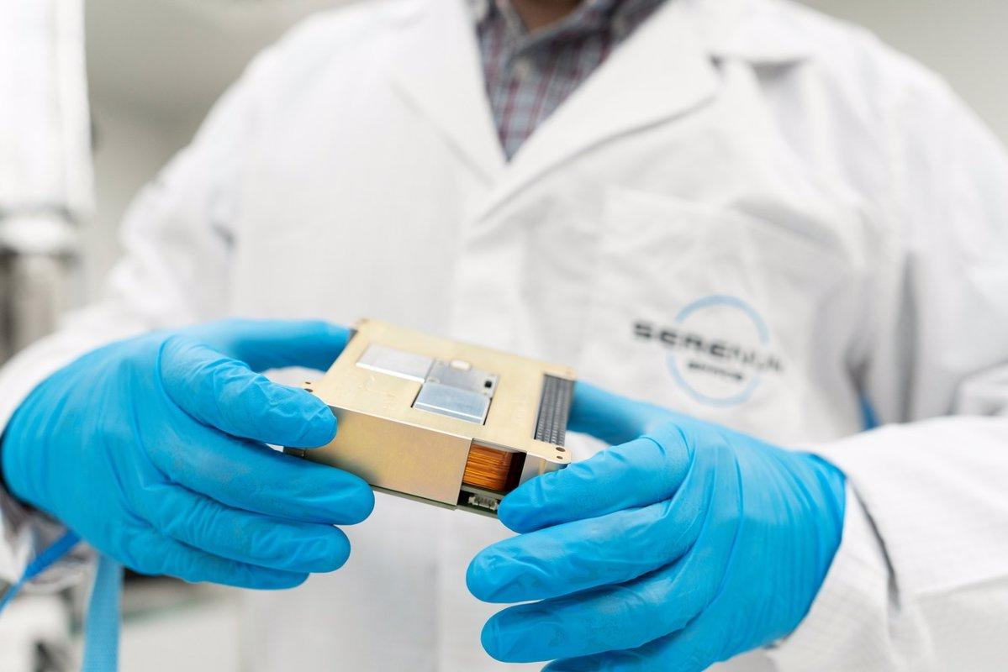

*Figure 12.1: The central unit; the 3 reaction wheels can be seen fitted into the top.*

## Components

The VAC02 has 3 reaction wheels and 3 magnetorquers for actuation, as well as 3 or 6 sun sensors, 3 3-axis gyroscopes, and internal/deployable 3-axis magnetometers. The VAC02 comes with a central unit which sits in the stack (PC104 compatible), external sun sensors (3 or 6), and optionally an external deployable magnetometer. The central unit contains two boards, a motherboard and a magnetorquer control board, as well as the actuators (3 reaction wheels and 3 magnetorquers), and the sensors (3 gyroscopes and 2 internal magnetometers). The external deployable magnetometer consists of a heat knife release mechanism, a sun sensor and the magnetic sensor. If included, it would be mounted to the side of the CubeSat and connected to the central unit via cable. Serenum also offers larger reaction wheels for higher torque and increased momentum storage for larger CubeSats; we may use these, expanded further in the Pointing section (6.10). The Engineering Model can be one of two options. The first is a “Light EM” which consists of just the central unit with mock, aluminum reaction wheels. The second is identical to the flight unit but has not undergone acceptance tests and contains lower grade components.

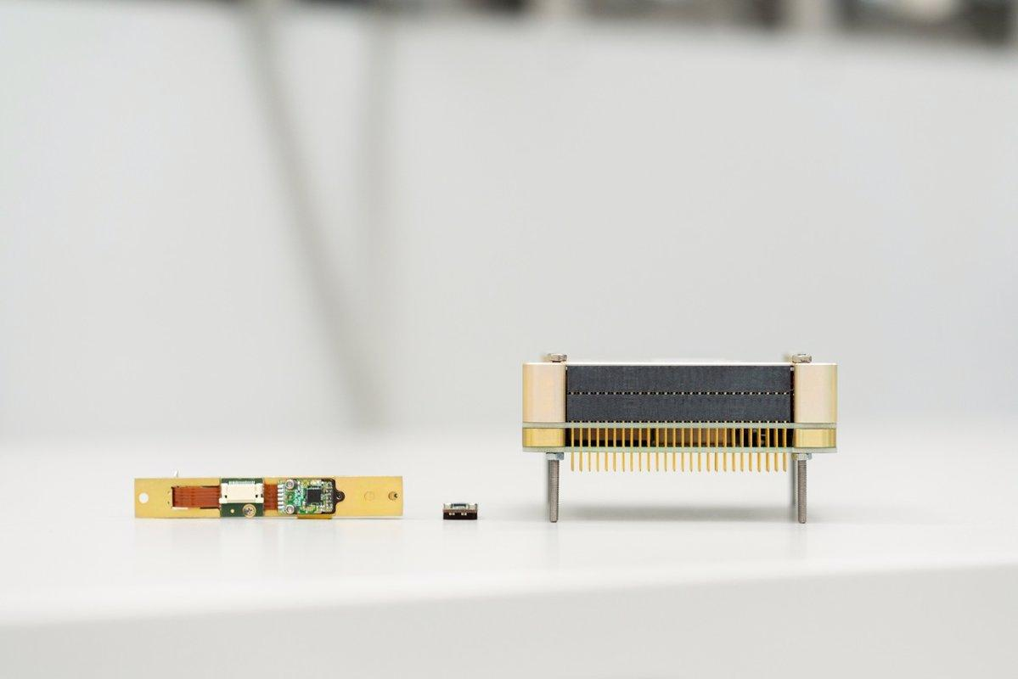

*Figure 12.2: From left to right, the external magnetometer with built-in*

*sun sensor, a single sun sensor, and the central unit.*

## Configurability

The configuration options available to us are:

1. The number of Sun sensors (3 or 6)
   1. Explained in pointing.
2. Communication interface type (CAN, I2C)
3. Reaction wheel motor type (5V or 8V)
   1. Motors for the reaction wheels can be configured to use 5V or 8V. Recommended is 5V, but the 8V version is offered for those using 2S LiPo batteries. Cost and power consumption are identical for both variants.
4. External deployable magnetometer (yes/no)
   1. Using just the internal magnetometers increases noise and may degrade pointing performance. Using the external deployable magnetometer reduces that noise.
5. Various electrical options
   1. CAN bus termination resistors (yes/no)
6. Larger reaction wheels (yes/no)
   1. Offers increased momentum storage and larger torques
   2. Would likely be a yes to meet pointing requirements (see 6.10)
   3. Note that we do not have specifications for these and numbers in the rest of this document reflect the standard, smaller wheels.

Additionally, there are two types of sun sensors (NXSS3v10 or NXSS3v20), however they mention assisting us in sun sensor selection and placement and I believe they will recommend a type to use. (Will ask and verify.)

## Mass

The central unit has a mass of 414.4 g, with an external magnetometer adding an additional 9.9 g; bringing the total mass to 424.3 g. A small amount of additional mass should be budgeted for cables and sun sensors which are not decided as of yet.

## Dimensions

The central unit has dimensions of 27 x 94 x 94 mm (0.27U) and is PC104 compatible. The external magnetorquer dimensions are 82 x 12 x 11.5 mm (folded) and 82 x 12 x 79.5 mm (unfolded). Sun sensors dimensions depend on the type (NXSS3v10 or NXSS3v20):

* NXSS3v10: 15.5 x 15 x 4.5 mm
* NXSS3v20: 10.5 x 20.5 x 4.8 mm

Note that the dimensions for the central unit do not take into account the larger reaction wheels since we lack information on them.

## Interfacing

The VAC02 ADCS can communicate with either CAN or I2C. This can be changed at runtime by changing the routing table. Additionally, it can communicate simultaneously on both CAN and I2C. Sun sensors communicate on I2C. A 120Ω CAN termination can be added as an option, if we have the VAC02 at one end of the stack and are using CAN (required by the CAN protocol).

## Power Draw

The central unit takes 5V. Reaction wheels are designed to take 5.0V or 8.0V depending on motor type. Both versions have identical power consumption. The upgraded reaction wheels have a power draw of 450 mW at maximum momentum storage. The optional external magnetometer and sun sensors take 3.3V input power. Total power consumption depends on mode, see table below.

*Table XX: Description of table*

|  |  |
| --- | --- |
| Idle: | 375 mW |
| Nominal: | 960 mW |
| Peak: | 1400 mW |

## Radiation Hardening

Stated ionizing radiation tolerance is 36 krad.

## AI&T Feasibility

The main unit sits in the stack, with a height of 24 mm and is PC104 compliant. Other considerations are the external magnetometer, which, if included, must be mounted to the exterior and needs clearance to deploy. Their external magnetometer is also physically connected to a sun sensor, so where it is mounted should be considered carefully. The rest of the sun sensors must be mounted to the exterior, facing different directions. Finally, all the external components must be connected back to the central unit via FFCs. They recommended a specific cable for the external magnetometer.

## Pointing

The maximum torque it can supply for each axis is 0.2 mN*m. In terms of pointing error, the VAC02 ADCS is listed as having: Relative (jitter): 0.15° @ 1 Standard Deviation, Absolute (including jitter): 0.45°. Agility analysis from Serenum shows that this does not meet ground tracking requirements as is. To meet ground tracking requirements, Serenum has offered larger reaction wheels but these are more expensive and do not have flight heritage. Additionally, pointing can also be limited depending on the number of sun sensors used. At least one sun sensor must be illuminated to maintain attitude knowledge. Thus 6 sensors would allow Ex-Alta 3 to point in any direction, while 3 would reduce cost, harness complexity, but would limit the possible attitudes. Ondrej has mentioned they can “assist with optimal accommodation of [sun sensors] on your spacecraft.” They have also mentioned that we could meet ground tracking requirements by tracking in the x-axis (rolling the satellite) instead of the y-axis (pitching the satellite); this could be done with or without the high-performance reaction wheels.

## Documentation

We have a general specification sheet, which lists basic information regarding certain properties. Additionally, we have an Interface Control Document (ICD), which expands in detail on information required to integrate the VAC02 into a CubeSat (communication interfaces, physical dimensions, component information, electrical requirements). They also provide a user manual in the “post-contract” data pack.

## Technical Support

Our main point of contact is Ondrej; he has been responsive in answering our questions and promoting our understanding of the specifics of their system. They have mentioned they would help us with the sun sensor selection and can provide a more specific solution once they know more about our specific mission. It is assumed that they will continue to provide us with support should we continue with their system, but we have not dealt with them before.

## Price

The price from the quote, which is not included as it is under NDA, increases depending on how many sun sensors we need and what wheels we get, but is within our tentative budget regardless of configuration.

## Lead Time

Listed lead time is 24 weeks, plus shipping time. This was confirmed on Nov 7th, 2023.

## Lifetime

Expected lifetime is 3 years.

# Comparison

## Criteria Description

### **Price (8)**

Price is how much the unit costs and was given a weighting of 8 because a unit that is prohibitively expensive will not be considered, but there is some flexibility in the budget to purchase a slightly more expensive unit. The value given to each system is based on how expensive it is compared to the budget. Something that is significantly under budget will get a 9 or a 10, while something that is prohibitively expensive will get a 1 or a 2.

### **Mass (5)**

Mass is how much the system weighs and was given a weighting of 5 because while mass is important to the satellite, other aspects of the ADCS are more important and there is more margin in the mass budget. The value given to each system is somewhat relative, but is also based on how close it gets the satellite to the maximum weight, with heavier systems receiving a lower score.

### **Dimensions (10)**

Dimensions is how much room is taken up in the stack by the system and the size of the external sensors that accompany the ADCS, if any. It was given a weighting of 10 because the amount of space in the satellite is extremely limited and any extra room in the satellite to aid in AI&T is valuable. This criteria follows the same rationale as mass as they are both concerned with the physical construction of the satellite.

### **Interfacing (6)**

Interfacing is how the ADCS connects to the rest of the satellite physically and electrically. It was given a weighting of 6 because every ADCS for cubesats is made to the PC104 standard, and if it is something smaller a daughterboard can be made to accommodate. The electrical connections to the sensors also follow standard communication protocols, though some are better than others. A high score means that the system is PC104 standard and the connections to the sensors use robust communication protocols, i.e. CAN or UART; the stack header can also be configured to interface with the rest of the satellite.

### **Pointing (10)**

Pointing is whether the system meets our pointing requirements and was given a weighting of 10 because if the ADCS cannot point precisely enough then the main payload will give bad data. If the system meets our requirements then it is given a score of 10, and if it is close to meeting our requirements, then it is given a slightly lower score based on how far it is from meeting our requirements.

### **Configurability (4)**

Configurability deals with how many options there are for different sensors and sizing options for actuators. The weight of 4 reflects the fact that a base system that meets requirements does not need to be configurable, but having different options is convenient. A high score means there are many options to choose from for sensors and actuators, and a low score means there is only one or few options.

### **Technical Support (7)**

Technical support is how quickly and how well we can get questions answered by the manufacturer about the system. This is especially important during AI&T when there will inevitably be some questions about the system and having good support will make the process go smoother, hence the weight is 7. A high score means the company is quick to respond to emails and answers questions with good detail, and a low score means communicating with the company is difficult.

### **Lead time (7)**

Lead time is how long it takes for the ADCS to be in the hands of AlbertaSat from the time that it is ordered from the company. Given the short timeline of the mission, it is imperative that we have as much time as possible to integrate and test the ADCS with the rest of the system, so it is given a 7. The system should be on the bench in the cleanroom by September, and the score given to each system is based on how feasible that is given the current date.

### **AI&T Feasibility (9)**

AI&T feasibility is whether or not the system can be integrated into the satellite in the timeframe available. If it can’t be fitted into the satellite and tested before launch because there are too many steps or the integration is too complicated, then it could ruin the mission, hence it is very important and given a weight of 9. A high score means that it is relatively simple to integrate, should any issues arise they can be resolved, and it gives flexibility in the crucial budgets of the satellite.

### **Power Draw (8)**

Power draw is how much power the system consumes during operations and 8 given for weight reflects the need for the ADCS to run at peak performance during payload operations and during S-band downlink, both of which consume significant power on their own. The criteria follows the same rationale as mass, i.e. it is somewhat relative to the other systems, but it is also based on whether it meets the power budget and what the margin is.

### **Documentation (7)**

Documentation refers to what documents we have access to or expect to have access to for the given system. Given how important proper documentation is, especially for such a complicated system, this criteria was given a weight of 7. If the system has all necessary documentation and they are detailed, then the system received a high score in this category.

### **Radiation Hardening (3)**

Radiation hardening refers to how much TID the system can receive before giving errors. This is outside our control and is not as important to the lifetime of the system as compared to the reaction wheels, so it was given a weight of 3, the lowest of any section. The systems were scored relative to one another, with the best tolerance for radiation given the highest score.

### **Components (6)**

Components means what components are used in the system and the quality of said components, which affects the pointing control and knowledge accuracy attainable by the system, and was given a weighting for the table of 6. If the quality of the components is higher, the system received a higher score.

### **Lifetime (4)**

Lifetime refers to how long the ADCS can operate before starting to degrade and losing performance. The satellite will remain in orbit for close to a decade and no ADCS is designed to last that long so it was given a lower score of 4. The systems were again ranked against each other since all of them would lose performance far before the expected deorbit time.

## 7.2 Comparison Table

*Table 9: Weighted comparison of all the aspects of the ADCS modules under consideration. The weights and values were chosen by the ADCS team.*

|  |  |  |  |  |  |
| --- | --- | --- | --- | --- | --- |
|  | Company | CubeADCS Gen 2 | | Serenum Space | |
| Aspect | Weight (1-10) | Value | Weighted Value | Value | Weighted Value |
| Price | 8 | 3 | 24 | 5 | 40 |
| Mass | 5 | 7 | 35 | 10 | 50 |
| Dimensions | 10 | 4 | 40 | 10 | 100 |
| Interfacing | 6 | 9 | 54 | 8 | 48 |
| Pointing | 10 | 10 | 100 | 8 | 80 |
| Configurability | 4 | 9 | 36 | 6 | 24 |
| Technical Support | 7 | 9 | 63 | 7 | 49 |
| Lead Time | 7 | 10 | 70 | 6 | 42 |
| AI&T Feasibility | 9 | 4 | 36 | 8 | 72 |
| Power Draw | 8 | 6 | 48 | 8 | 64 |
| Documentation | 7 | 9 | 63 | 7 | 49 |
| Radiation Hardening | 3 | 6 | 18 | 8 | 24 |
| Components | 6 | 9 | 54 | 8 | 48 |
| Lifetime | 4 | 5 | 20 | 5 | 20 |
| Total |  | 100 | **661** | 104 | **710** |

The iADCS200 System from AAC Clyde Space was not included in the decision matrix, due to the cost of the system being prohibitively out of the ADCS allotted budget, and not meeting our functional requirements. The procurement of this system would not be feasible for the ADCS team, let alone AlbertaSat.

The ADCS-10m from Tensor Tech was not included in the decision matrix as it likely would not meet the power draw requirements. Additionally, the lead time to purchase the discounted version would put the team behind schedule by several months. Based on these two factors the ADCS-10m is not suitable for Ex-Alta 3.

The CubeADCS Gen 1 was also not included in the comparison matrix, mainly because of the lack of support expected for this system. This is because CubeSpace will be phasing out this system, along with its technical support. Previously with Ex-Alta 2, the ADCS team ran into AI&T and configuration issues with this system specifically, and it is expected to occur again with this system.

The CubeADCS Gen 2 scored a 661 weighted value making it the second best option for the satellite. It has the new component versions from CubeSpace, lots of detailed documentation and available technical support, and pointing capabilities. The downsides are that the price is significantly over our budget, by more than $10 k CAD, it doesn’t have flight heritage yet, and the size and mass of the system are close to the allocated budgets leaving little room for adjustment, and creates the possibility for AI&T problems.

The Serenum Space VAC02 scored a 710 weighted value, making it the best option for the satellite. Its primary strength is the cost, as it is well within our budget, even if we get the 6 sun sensor version with the larger wheels. Additionally, its power consumption is below budget by a good margin and has strong radiation hardening. However, we have no experience with their hardware, which is a mix between different companies for the larger wheels, and the level of detail and quality of their documentation is unknown for the user, firmware and commissioning manuals. Finally, the lead time on their system is 24 weeks+shipping, meaning we need to order by early/mid-March to get it on the bench for September 1st.

# Recommendation

As a result of the information listed above, the CUBICS ADCS team recommends that the Serenum Space VAC02 system, with the higher performance Wittenstein reaction wheels, be procured and integrated into Ex-Alta 3. While this is the first time AlbertaSat has had contact with Serenum Space, the professional relationship between AlbertaSat and Serenum is developing nicely having had lots of discussion via email and a video call to discuss the system. Additionally, the lead time for receiving a flight model VAC02 system is approximately 24 weeks, allowing for the team to stay on schedule with AI&T. A simulation has already been completed with our current mission parameters, and Serenum has determined that our pointing requirement will be met using their system with the better wheels, while the knowledge requirements are close to being met. The system is at the maximum of our budget with contingency, making it reasonable to purchase, but additional funds will need to be allocated for additional costs. The size of the system is a big advantage as it is only 0.27U for the main stack and the external sensors are small and can be easily integrated into the satellite. The power draw is also within budget, even considering the additional draw from the new wheels. Considering all aspects of the system, we recommend going forward with this system, primarily due to the small size and lower power draw, along with the higher performance wheels.

# 

# Reference Documents

|  |  |  |
| --- | --- | --- |
| **Ref. No** | **Document Name** | **Description / link** |
| **1** | EX3 System Requirements Table and Verification Matrix V0.1 | [EX3 System Requirements Table and Verification Matrix V0.1](https://docs.google.com/spreadsheets/d/1JsYgYUZo2joSWvbKcTxyhjZ5obwPhRHUQoW0HCoKc18/edit#gid=690074995) |
| **2** | ADCS Decision Comprehensive Overview V2 | <https://docs.google.com/document/d/1WDv9ih91w686EMW7uWMTa67YX3uatO9CrmLAlkgqIds/edit> |
| **3** | AAC Clydespace iADCS200 system website page | <https://www.aac-clyde.space/what-we-do/space-products-components/adcs/iadcs200>  *(NOTE: all referenced datasheets are available on this web address)* |
| **4** | Datasheet for ADCS-MTQ, ADCS-10m, ADCS-20m, and ADCS-40m | A datasheet provided by TensorTech detailing the specifications of each of their ADCS systems |
| **5** | ADCS-10m website page | [https://tensortech.co/product/category/adcs-series#](https://tensortech.co/product/category/adcs-series)  (The brochure and CAD model for the ADCS-10m can be found on this site) |
| **6** | CubeSpace Gen 1 system website page | <https://www.cubespace.co.za/products/gen-1/integrated-adcs/cubeadcs/>  (All reference documents for the gen 1 system are available from this page) |
| **7** | CubeSpace Gen 1 system ICD | <https://www.cubespace.co.za/downloads/cubeadcs_-_icd_v7.4_.pdf> |
| **8** | CubeSpace Gen 2 system website page | <https://www.cubespace.co.za/products/gen-2/integrated-adcs/cubeadcs/> |
| **9** | CubeSpace Gen 2 system ICD | <https://www.cubespace.co.za/downloads/cs-dev.icd.ca-01_cubeadcs_standard_icd_ver.1.01.pdf> |
| **10** | Serenum VAC02 specification sheet | <https://www.serenumspace.com/products/vac02-adcs> |
| **11** | Serenum VAC02 Interface Control Document | Under NDA, contact an author for access |
| **12** | Volume Budget | [EX3-MC Satellite Volume Budget V0.10](https://docs.google.com/spreadsheets/d/1Lh1-7ZAQAlGilMSKbkDtGGH6dmtKhZuuyHqBW8kSr0A/edit#gid=1090945145) |
| **13** | Mass Budget | [EX3-MC Mass Budget Ver. 0.10](https://docs.google.com/spreadsheets/d/1Il7Kk25vSafTMIIROnqKp8JwfkxfXPPihbgZBXDLVzI/edit#gid=1419579776) |
| **14** | Power Budget | [EX3-PW Power Budget V0.01](https://docs.google.com/spreadsheets/d/1xm6lyxn-siyKKDMp24kGk4-iLS8qrYAUId-4PxGPHUs/edit#gid=893585010) |

# 

# Appendix